Talking Magazine
By DarrenHunter.Net 2010 - 2011(c)

Install
After you have downloaded and extracted the zip file you will need to click on the setup.exe file and follow all on screen instructions.
YOU MUST HAVE AN ACTIVE INTERNET CONNECTION TO INSTALL THE PROGRAM AS IT DOWNLOADS SECTIONS OF THE .NET FRAME WORK.
Once the software is installed you will find that an icon has been placed on the desktop called Talking Magazine there is also an icon in start then all program then Talking Magazine then an icon in there called Talking Magazine.
This is if the default location was used and a customer install was not done.
Install: System requirements
Windows XP or above (tested on XP and Win 7)
Memory: 1GB
HDD:10MB
Video: 128MB
Printer: Optional
Label Printer: Optional
Getting Started
As Stated above you will need to click or double click depending on the icon you choose to start the software.
Getting Started Log-in to Talking Magazine
The talking magazine data is protected by a 128bit encryption code that needs to be set for both the users and the customer / members both codes can be the same or different. See customer section later in manual.
When you first start the software the login screen will be displayed please see fig 1.
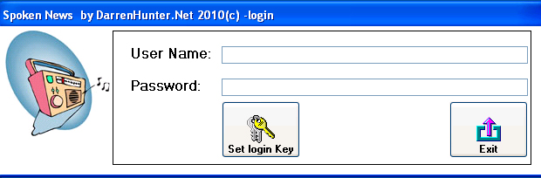
Fig 1
You will need to set the login key to do this click on the set login key button this will open a new window see fig 2.
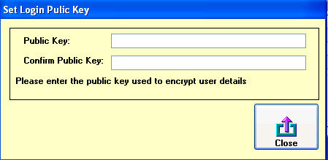
Fig 2
Here you will need to set a 32 Character key that will be used to encrypt the users details. Once you have set the key click close.
This will return you to the main login screen.
The default user name and password are:
UserName: admin
Password: letmein
Type these in to the username and password box and then click on the login button this will then let you access the talking mag database.
Talking Magazine Main user interface
The main user interface is the heart of the system this is where as a user or database administrator you can access all the functions of the system.
Please note at this point if you are logged in as a user and the system administrator has lock out specific functions in the database then you may not have access to all the functions of the database that have been explained in the manual.
Also note: If a service pack / revision has been installed then some of the functions in that version of the software may differ from the user manual we will endeavour to keep the user documentation as up to date with the software that you are using but the documentation may be a little out of date if new features are been worked on and or a bug fix is released for the system.
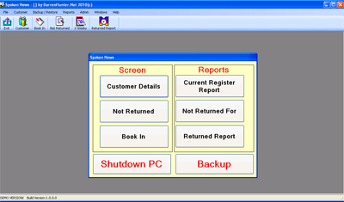
Fig 3
Before you can enter the customer details section you will need to add the following:
- You will need to set the public key (Used to encrypt the customers details)
- Title
- Eye Condition
- Media
- Player Type

Add Public Key
To add the public key click on the Admin menu and then public key this will open the following form.
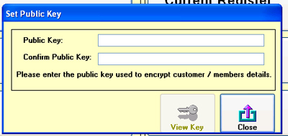
Fig 4
Here you can enter a key it needs to be 32 characters long. Once you have set the key click on close and this will save the key to the system.
If you need to know what the key is click on the view key button.
NOTE:
Once the key is set you can't change it.

Adding / Editing Titles
To access the Title (Salutation) click on the admin menu and then click on the Title menu option the following screen is opened.
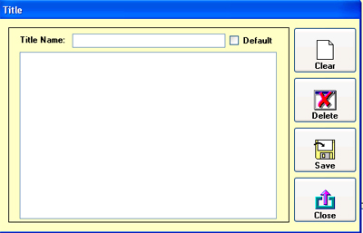
Fig 5
To add a new title enter the title name in the text area and then click save, this will check to see if the title is in the database already if the title was found then it will display a message telling you that the title was found.
If you want to make the title the default title click on the default tick box. This will then set this as the default title when it is saved.
To edit a title double click on the title in the list of titles.
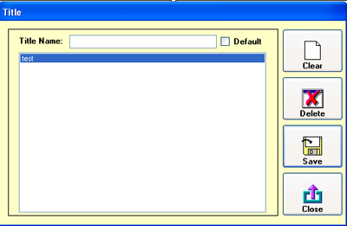
Fig 6
This will fill in the text area with the name of the title it will also tick the check box if it set as the default item. Make any changes and then click on the save button.
To delete a title select a title and then click on the delete button this will delete the title.
Note:
All windows that are designed in the same way as the add / edit title will function in the same way.
The following forms work in the same way so it not coved in this manual
- Title
- Eye Condition
- Media Type
- Player Type

Eye condition
To access the Eye condition section window click on the admin menu and then click on the eye condition menu option this will then open the eye condition section. As stated above this works in the same way as the title screen.
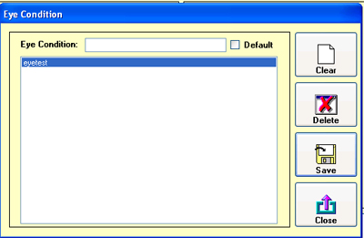
Fig 7

Media Type
To access the media section click on the admin menu and then click on the Media Type menu option this will then open the media type window.
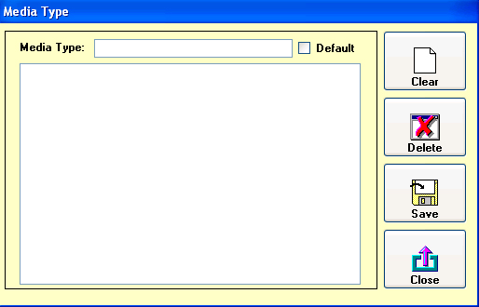
Fig 9

Player Type
To access the player section click on the admin menu and then click on the player type menu option this will then open the player type window.
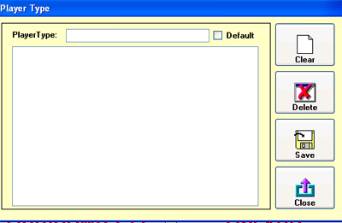
Fig 10

Address Line
The address line section is designed to allow you to specify how many lines a user can access on the customer screen.
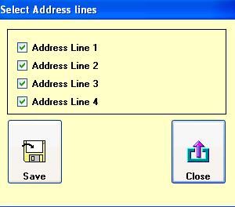
Fig 11
Un-tick the lines that you do not want your users to have access to and then click save. Then click close. Once you have done this you may need to open and close the customer screen if you have it open.
Compact and Repair Database
This will compact and repair the talking magazine database, you must make sure that you make a backup of the database. The software developer or darrenhunter.net will not be held responsible in any way for loss of data by using this function.
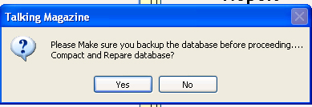
Fig 12
The above message will be displayed when you click on the compact and repair option under the admin menu. If you click on no then it will just close.
If you click on yes then the working message will be displayed and the database will be compact and repaired.
Edit Speech Message
The edit speech message allows you as a system administrator to specify if the system uses a wave file or use the speech synthesis to play a message to the user when they are book in / out a magazine to customer.
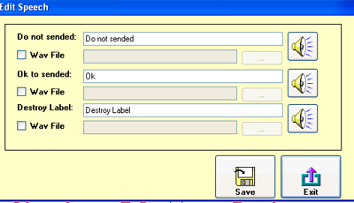
Fig 13
To select a wave file click on the corresponding check box then click on the "..." button to locate the wav file. If you like to hear the wave file click on the speaker button and this will play it. If you want to use the speech function type in what want the system to say and then click on the speaker button. Once you are happy with the settings click save.

Edit Voice
Edit voice allows you as a systems administrator to check the style of speech used in the system.
When the option is clicked on from the admin menu and then clicked on Edit Voice the following screen is opened.
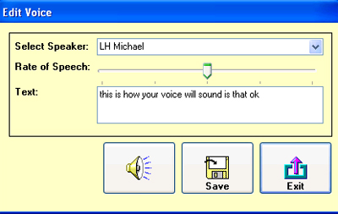
Fig 14
To select a voice click on the drop down list next to select speaker, this changes the voice that the system uses.
You can also change the rate of speech by changing the rate of speech option and there is a text area with a default message to be said / played.
To hear the voice click on the speaker button.
Once you are happy click on the save button.

Equipment
The equipment section is where you add any players that will be assigned to a customer.
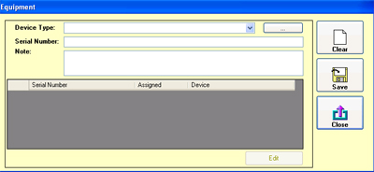
Fig 15
To add a new item of equipment select the device type from the device drop down if there are no devices in the drop down or the device you want to add is not on the list then click on the "..." button to the right of the drop down.
This will open the device type add / edit screen. This screen works in the same way as the other add / edit screens.
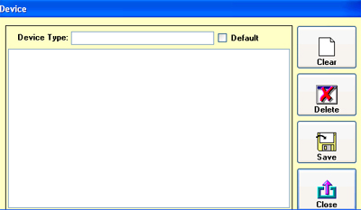
Fig 17
Once the device type been selected or added then click on the serial number text area and then enter the serial number and then enter any notes in the notes section. Click the save button to add the new device.
This screen also shows which devices are assigned to customers and the devices that are free.
To edit a device select the device from the grid and then click on the edit button and then make any changes and once you are happy with the changes click on the save button.
Export Database
The export function can be used to export the database to either a CSV file or a XML file. This also exports the database in an un-encrypted format.
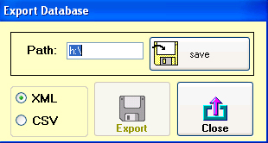
Fig 18
Set the path where you want to export the csv, xml files to and click the save button and then click on the export button this will dump the files to a location where you have specified.

General Options
The general options are used to switch on / off the spell check and the post code check.
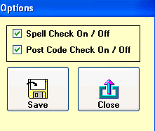
Fig 19
Once you have made your changes click on the save button.
Import Unencrypted XML
This will import the xml files that were exported.
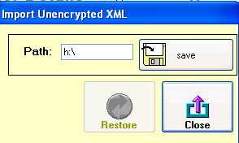
Fig 20
Set the path where the xml files are located and click on the save button then click the restore button. This will import the xml files in to the system. This may take some time depending on the amount of data you have in the system.
Shutdown Method
The shutdown method is used to specify the way in which your system is shutdown.
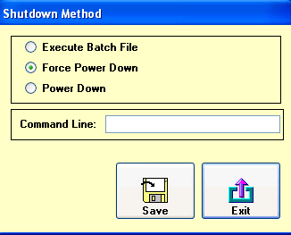
Fig 21
Force Power Down and Power Down use the WMI API in windows to execute the shutdown of the system. The execute batch file is used if you want to use a 3rd party tool to shutdown windows or you have problems with the other two methods.
Note:
In the folder where you installed the database there is a batch file called shutdownpc.bat that executes the shutdown protocols.
Once you have made the changes you want to make click on the save button.

User Admin
The user admin section allows you to specify the permissions for each user who uses the system.
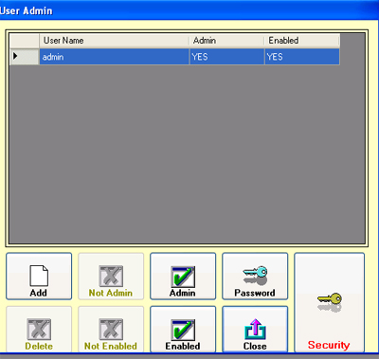
Fig 22
Note:
Any one set as admin has full access to the system.
To add a new user click on the add button this opens the following screen.
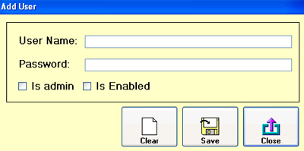
Fig 24
Type in the username and the password, then click on the admin tick box if the users is an administrator. Then click on the enable tick box to enable the account and click save. This will add the user to the system.
All the other buttons on the main security window are fairly self explanatory the only button that needs to be explain is the securer matrix button this is used when a person is set as a normal user.
When the security button is click on the following window is opened.
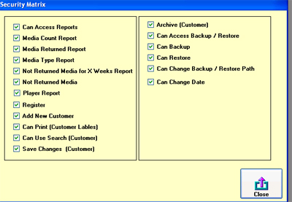
Fig 25
By un-ticking the boxes you do not want the user to have access to this will lock the function sections that the user can access.
Then click close to save the changes.
Backup / Restore
The backup and restore options used to make a backup of the database and restore the database to a previous state.
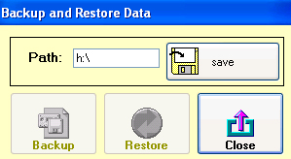
Fig 26
Set the path where the database is going to be backup and restored from.
To backup the database click on the backup button this will backup the database.
To restore the database click on the restore button this will restore the database to an earlier version. Once the database was restored the database will be closed and you will need to reopen it.

Customer
To access the customer screen click on the customer button on the main navigation form.
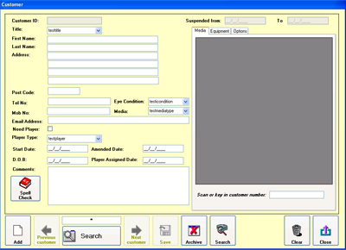
Fig 27
To add a new customer click on the add button.
To navigate through the customer records click on the previous and next buttons. (By default they are not available if you only have no customers or a single customer setup in the system. If there are multiple customers setup then they are available.)
The save button by default is not available this button will only come available if the records edited and you need to save the changes made back to the database. The button will come unavailable after the changes are saved.
Archive button archives the customer, when the button is click on the system asked if you want to archive the customer if you answer "Yes" then the customer is archived.
Search - there are two search options the first is to use the quick search option by enter a customer name or number in the text area that contains the "star" and then pressing the search button under that this will then try and find the customer you want.
If you want to carry out a more specific search click on the search button next to the archive button this will open the main search window.
Clear clears the form and returns the system to the first record in the database.
Close closes the customer screen
Add new Customer
When the add button is pressed you will be asked if you want to add a new customer if you click yes then the new customer window will be displayed.
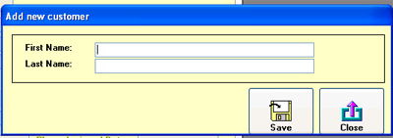
Fig 28
To add a new customer fill in the first and last name and then click save. If you do not want to add a new customer just click on close.
Advanced Search
When the search button is clicked on (one next to clear) the following screen is displayed.
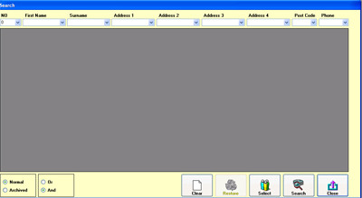
Fig 29
There you can select the parameters' you want and then click on the search button, this will then search the database and see if there is any matches, once you have got the customer you want click on the row and then press the select button.
To close the search screen without displaying a customer click on the close button.
The one major function that this search screen does is allows you to search archived customers, if you select the archived option this will show records of customers who have been archived. This is designed so that you can restore that customer by selecting the customer in the same way as a none archived customer then instead of clicking selects click on the restore button.
Booking Magazine in and out
To book a magazine in and out, select the media tab on the customer screen and then enter the customer number in the text area next to "scan or key in customer number" then press enter this will then add a new record for a magazine in to the database.
If you are using bar codes and you have a barcode scanner then this will automatically add a carriage return to the line and should book in / out a magazine without you having to press enter.
Booking Equipment in and out
To book an item of equipment out to a customer select the equipment tab and then enter the serial number in the text area and press enter.
This will check the database to make sure it is not assigned to someone if it is then it will display a message and not allow you to book it out to the new person.
If the equipment is not assigned then it will assigned it to the customer.
To return the equipment for a selected customer make sure you are on the correct customer and follow the same steps as you did to book out the equipment this will book it back in to stock.
Suspend a customer
To suspend a customer select the options tab on the customer screen and select the suspend period by clicking on one of the suspend buttons. You also need to be in this screen to remove suspension.
Note:
When the system starts it checks the database and removes any suspension periods that have expired.

Not returned
This opens a window that shows customers who have not returned a magazines.
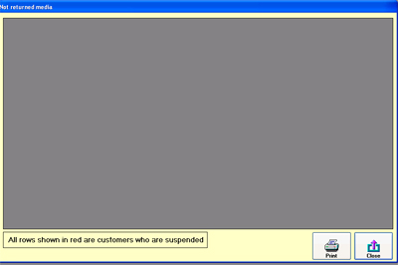
Fig 30
Book in magazine
This opens the customer screen and sets the focus on the "scan or key in customer number" text area. Do the same as above for booking in / out a magazine.
Customer Register Report
Opens the print window and shows the customer register.

Not return for
This generates a report for customers who have not returned a report for a specific number of weeks.
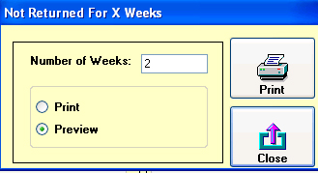
Fig 31
Enter the number of weeks you want to generate the report for then select if you want to preview it or print it.
Then press the print button.
Media Return Report
This checks the system for a specific week and generates a report showing how many magazines where booked in or out on that week.
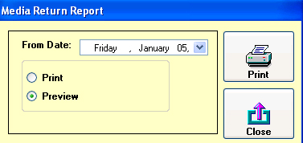
Fig 32
Works in the same way as other reports except you need to select a date from the calendar.

Media Count
This opens a media count window that shows media booked in and out for a specific week.
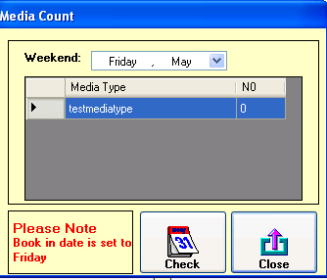
Fig 33
To select a week click on the calendar at the top of the form and select the week and then click on the check button.
Media Type Report
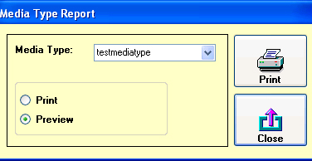
Fig 33
This report is used to show which customers are using which media type, select the media type from the drop down list and then select print or preview and then press print.
Player Report
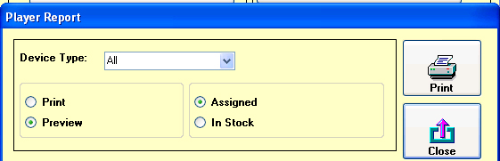
Fig 34
Select the parameters' you want to generate the report based on and then select print or preview and then click print.
Register
To register the software click on help and then register and the following window will open.
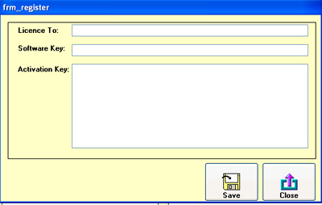
Fig 35

Enter the details per the registration email and close and re-open the software and you will have a register version of the software.
Limitations
If the software is been used in demo mode then you can only add 20 customers.

